III Республиканский открытый конкурс творческих работ
“Мы победили!”

Номинация “Война в судьбе моей семьи”
“We Remember! We’re Proud!”
“Мы помним! Мы гордимся!”

Горобец Алексей,
МБОУ «Гимназия № 13», 10 класс,
Ново-Савиновский район, г Казань
Руководитель Шарипова Л.Р.

Казань 2022
Contents

Introduction.............................................................................................................. 3
How it all began................. ........................………..................................................5
Great-grandfather’s life............................................................................................ 6
Conclusion……………………………………………………………….……........8
The list of used sources and literature ......................................................................9
Applications……………………………………………………………………….10

Introduction

The great Patriotic war is a grief for lots of people, the most terrible and bloody war in the history of our country and the whole world. About 26 million Soviet soldiers and civilians died in that war.

The theme of our research work: "Different destinies-one victory".
The relevance of this topic: every year the number of those who took part in the war and those who worked in the rear decreases. Unfortunately, many people forget those difficulties. In order not to repeat the mistakes of the past, in order to live in peace and harmony, we must remember those who sacrificed their lives for our existence on the Earth.
The object of the research: to find information about great-grandfather who took part in the Great Patriotic war. We should explain the significance of the Victory Day.
The hypothesis of the research work is that if we forget our heroes and the events of the World War II, we won’t be able to preserve the history and customs of our country. And what’s more, younger generation won’t know the significance of Victory Day.
The basic purpose of the work is to find information about the great-grandfather who participated in the Great Patriotic war. To remind ourselves the significance of the Day and commemorate our heroes who were involved in the wartime events. Photographs, records archive were used as research methods.
The practical value of the work lies in the fact that the collected information can be used in writing war-themed essays, making reports and projects.
The novelty of the work is that it allows to improve our knowledge about the countrymen who made a worthy contribution to the victory over fascism.

Tasks:
- To find information.
- To examine various documents related to my family.
- To analyse collected materials.
- To attract the attention of my relatives, friends and acquaintances.
- Preserve the memory of one of the soldiers of the great Patriotic war.
- Create a sense of pride and respect for those who sacrificed their lives for us.

Research methods: analysis of collected information, studying various sites, interviewing relatives
Research problems: a lot of information is not written or simply we don’t know it; the younger generation does not show interest in veterans and the history of their country
Hypothesis: we believe that our research work will be able to attract the attention of my great-grandfather's countrymen, who still remember the war. If people of my village can memorialize at least some information about the relatives who took part in the war, then we will be able to preserve the truth and memory of those terrible times.

Main part.
How it all started
I wanted to have a look at the past, because through the past you can find answers in the present. Being interested in this topic, I had a wish to continue the research. You know…family research isn’t just clicking on the internet and looking for the statistics who lived where and when. It involves researching old photos, old boxes or even drawers!
How did it start:
1.When I was a child I remembered that my great- grandfather had mentioned about the Great Patriotic war. But many things had been forgotten… Once we went to Zelenodolsk to visit my great-granny. I’ve discovered a lot of photos in my great-grandmother’s house. I’ve known that she put everything into a drawer. And at the bottom there was a very old photograph. It was the photo of my great-grandfather Yuri Illarionovich Krivoruchko.( Application 1)
There I found an interesting article about my great-grandfather in the newspaper. Having read it, I realized I know very little about him. I asked questions to my relatives and soon I’ve got a complete story. So, my curiosity helped to discover a lot of important information! (Application 2)
2.I translated the article to insert it into my research paper.
3.I included in my text some information taken from the Red Army book.
4.Then I was advised to study one of the sites.There was described the battle in which my great-grandfather took part. To be honest, I was surprised by the information I found. Unfortunately, this information was previously forbidden. But nowdays everyone can read about the performed exploits of those who protected our country, who fought for the peace all over the world.
5.Later, I had to study additional literature.
Though, this is only a small part of what I’ve learned, it makes me feel proud of my ancestor.

Great-grandfather’s Life.
On June 22, 1941 a war threatened over our Homeland. From that day there was not a single house or family, who wasn’t affected by this great disaster. Sons, brothers, fathers and grandfathers went to the front. The war left many children without fathers, wives without husbands. Women and children, trying to help the front, worked tirelessly in factories and fields. Most of the civilians, especially women and children, worked days and nights on plants and factories, producing weapons, bombs, clothing, ammunition, shells, food, parachutes, grenades, shoes, and other essential things for the warfare. They worked for 12 or even 14 hours daily, everybody wanted to help his country. Most of the women were engaged in hospitals, taking care of thousands of helpless soldiers, brought from the battlefield. Overall, civilians played an essential role the whole period of World War II.
I would like to tell you what contribution my family made to the victory. The beginning of the Great PatrioticWar. That time my greatgrandfather Yuri Krivoruchko, the 16 year-old ukrainian teenager, had just finished the 8th form and worked in the collective farm. He remembered: “On June 21, I with my friends, the residents of the village Belilovka Vinnitsa region, were working in the field. It was evening, we didn’t finish the work, wanted to continue it next day. But in the early morning on the 22d we saw flying planes which were shooting. We found out that the war began.”
In two weeks the fascists had already been in Belilovka. Firstly, the enemy was loyal to the local people, but after the Stalingrad Battle they became fierced. The severe occupation had been lasted for two years. All the Jews were taken out from Belilovka. Most residents were taken to Germany. Among them was Yuri’s sister. Fortunately, she got to the farm in Poland, married there to a polish guy and stayed there with her new family. Later she entered the medical university and worked as a doctor. Naturally, we can say that there are not so many stories with happy end.
Finally, Vinnitsy region was set free from fascists. This region was an important communication centre and fasсists’ strong bastion of defense. When the Sovet solders came, they thoroughly checked everyone to know what residents were doing during the occupation.
So, Yuri went to the army. My greatgrandfather became the soldier of the 2d batallion, the 95th regiment, the 31st devision. He told that from March 1944 he fought in the3d Belorussian front. He was machine-gunner, he was proud that. His machine gun was the most modern one for that time. (Application 3)
1944, the 23st of June. It was very hard, severe fightings take place in Ukrain. The troops of the 3d Belorussian front supported by aircraft stormed the industrial center Vitebsk. The greatgradfather especially remembered the attac for the railway station in Molodechno, where they fought hand-to-hand with the fascists. Yuri found himself face to face with the fascists again, but now he had a weapon in his hands. That's where violent hatred for the enemy spilled out…
I became interested in the battle, for which my great-grandfather received the medal "For Bravery". “We came to the Neman River on the 13th of July 1944. The bridge was blown up. Captain Lozhkin ordered to build a raft and cross to the other side to cover the soldiers. And so, 12 soldiers, putting down their weapons on a raft, crossed the river. Early in the morning the fascists began to attack. Vlasovtsy are ahead.” Our soldiers could’t retreat, they had to fight. Yuri and his comrades were able to fulfill the order of their captain. In the battle he received the third wound, the most severe. (Application 4) He was treated in the hospital for eight months. Captain Lozhkin presented Private Krivoruchko to the medal "For Bravery" for this battle. But the captain died the next day… I’d like to add that my grandfather received his medal "For Bravery" only in 1982, 38 years after the war. (Application 5 a, b)
In war many soldiers realized that every day might be their last day, so each of them tried to leave more memories by sending letters home. My great-grandfather also sent letters, photos, and each time he thought that these were his last words to his family (Application 6)
After his recovery, Yuri remained working in the hospital, in 1947 he left to work in Western Ukraine. He worked in forestry. Bandera members shot at him more than once, but fate protected the young man.
Then he returned to his neighborhood, fell in love with a girl with an unusual name Militina. She was a young teacher, taught mathematics. "I'm going to marry her," -Yuri immediately decided. Militina is my great-grandmother, they lived for 43 years, raised two children.
My great-grandfather worked for more than 30 years at the factory named after Sergo (Application 6) There are several interesting cases from that time. He mined granite for the cladding of the Monument of Glory on the square near the Sergo plant. By the 40th anniversary of victory in the Great Patriotic War, it was necessary to build an obelisk. Time was running out, and there was no granite. Then my great-grandfather went to the factory in Belichi in Ukraine. However, granite could not be exported outside of Ukraine. He persuaded and even appealed to the minister, but the granite was brought! (Application 7)
The famous roses that decorated the plant even before the beginning of the 90s. This is also the merit of my great-grandfather. He got 2,500 cuttings of roses.
Yuri Illarionovich Krivoruchko lived a long and happy life with his family in love and care. My great-grandfather was respected by everyone, because he was a very well-mannered, educated and intelligent person.

Conclusion

During our research work we could find a large amount of material about the war. Thanks to them we can see that in those terrible years everyone was ready to sacrifice his life for the defence of the Motherland, for Victory, for a peaceful sky over your head. The young generation knows the price of this Great Victory, understands the significance of the holiday celebrated on May 9. Unfortunately, some information was lost before reaching us. In further research we will continue to study my great-grandfather's life. The Soviet people won that war, and it couldn't have been any other way. Our people did not want any war and did not want to kill. They protected our homeland. I am very proud of my great-grandfather. He made a huge contribution to the victory over Nazi Germany. Now we can learn from the mistakes of the past. I really hope that people will be wiser. They will stop destroying each other, no wars will happen in the future After all there will be no happiness from what was achieved by force. The great Patriotic war is the biggest example to prove.

The list of used sources and literature.
- Илык В.А. (Our victory: Military-historical chronicle- «Moskoviya», 2009. - 264 p.: Il.)
- Newspaper “Zeleniy Dol”, 19th May 2005
- https://pamyat-naroda.ru (the memory of the people)
- http://podvignaroda.ru (the feat of the people)
- http://dp60.narod.ru (Get Up, the country is huge!)
- https://iremember.ru (Memories of veterans of the great Patriotic War)

Applications
Application 1. My great-grandfather Yuri Illarionovich Krivoruchko

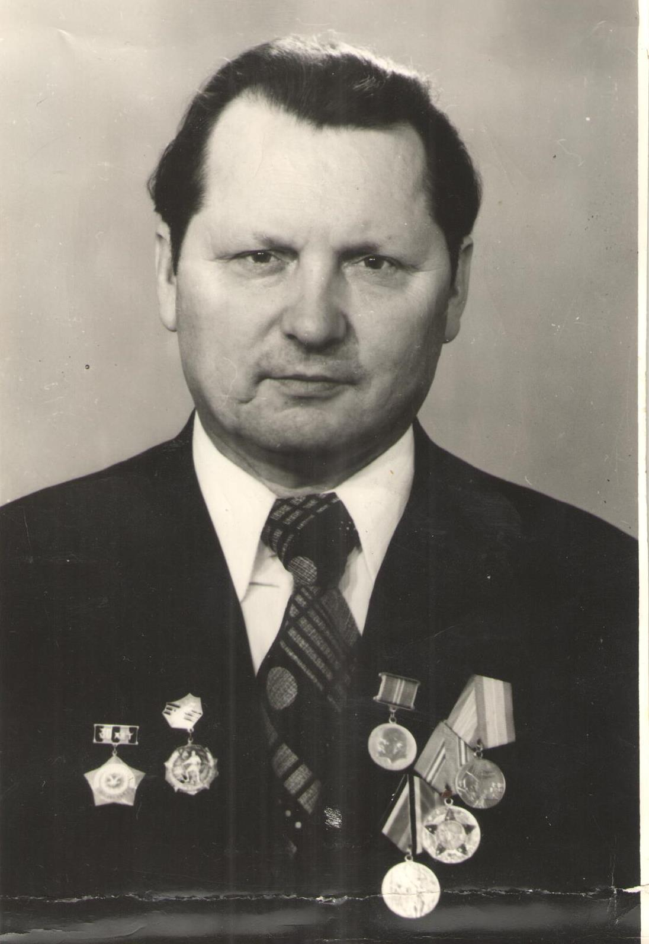

Application 2 The newspaper “Zeleniy Dol” (from 19th May 2005)
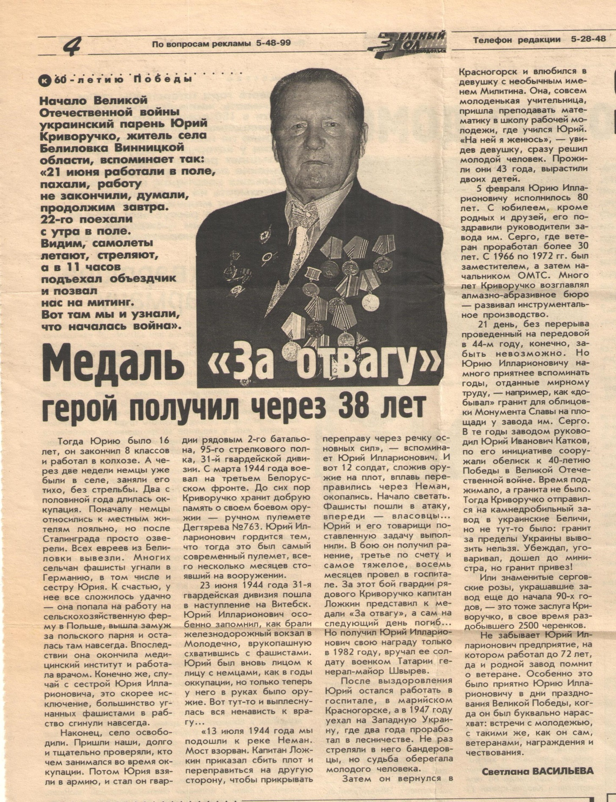

Application 3 Document from the site https://pamyat-naroda.ru
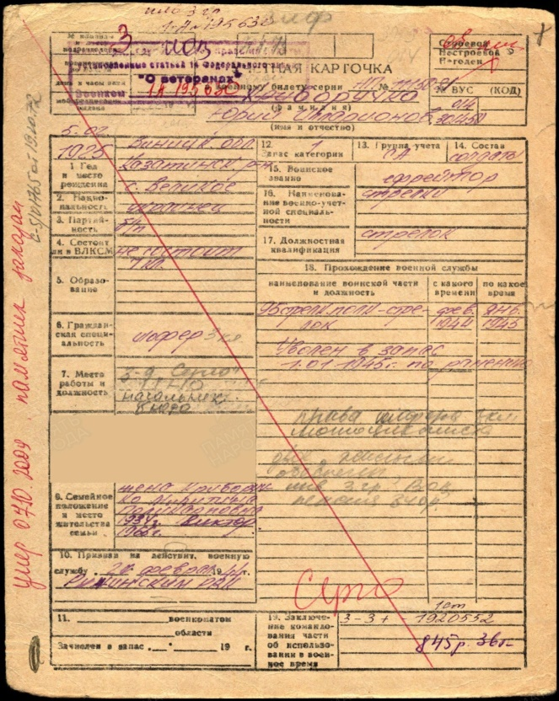
Application 4 Document from the site https://pamyat-naroda.ru
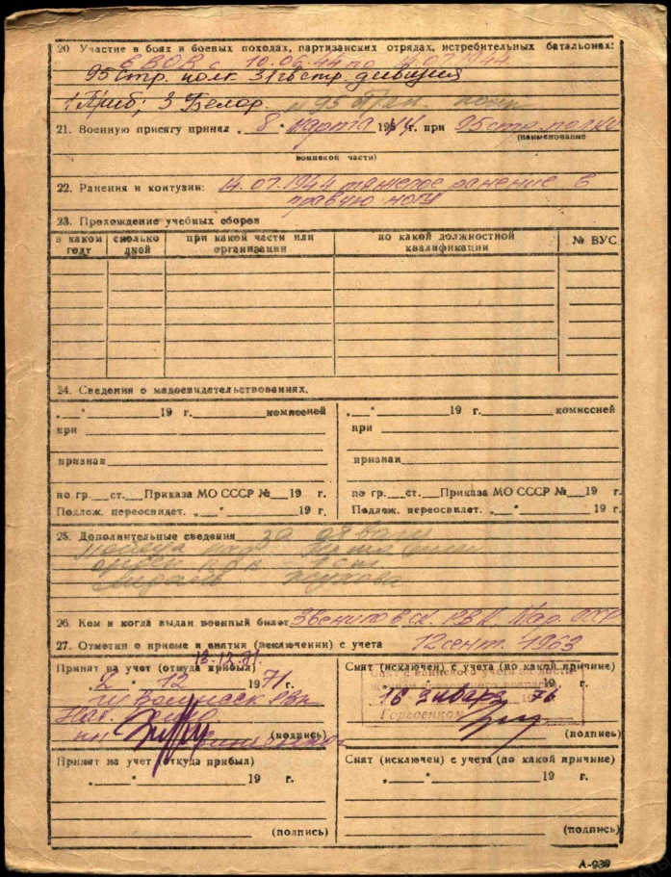

Application 5(a,b) Award Documents (https://pamyat-naroda.ru)
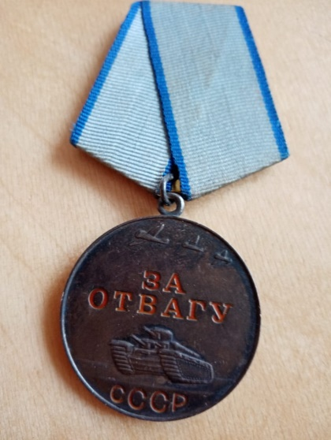
Криворучко Юрий Илларионович
Наградной документ
Дата рождения: __.__.1925
Воинское звание: ефрейтор
Кто наградил: Президиум ВС СССР
Наименование награды: Медаль «За отвагу»
Дата документа: 26.11.1981
Информация об архиве -
Архив: ЦАМО
Картотека: Картотека награждений
Расположение документа: шкаф 46, ящик 18

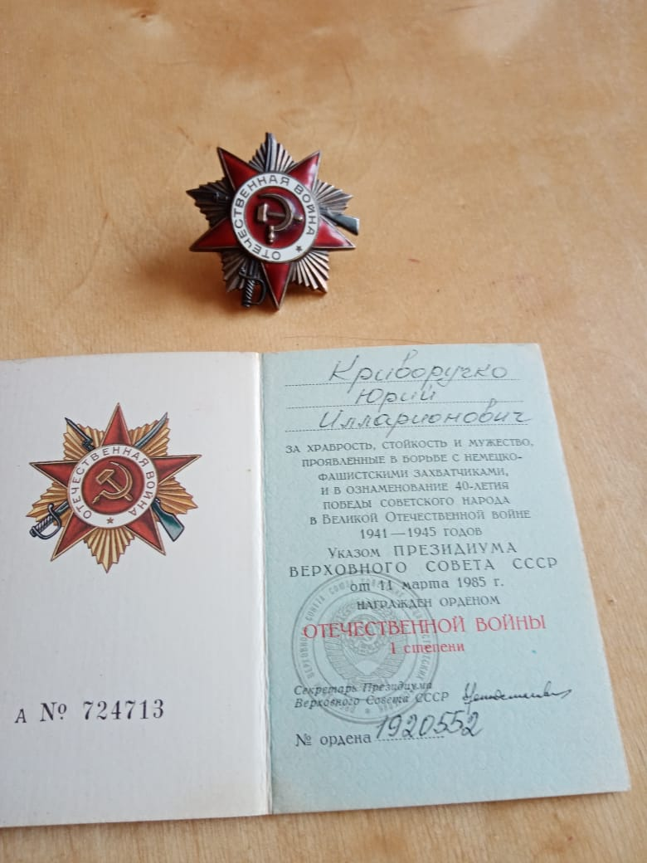
Криворучко Юрий Илларионович
Документ в юбилейной картотеке
Дата рождения: __.__.1925
Место рождения: Украинская ССР,
Винницкая обл., Казатинский р-н
Наименование награды: Орден Отечественной
войны I степени
Номер документа: 84
Дата документа: 06.04.1985
Автор документа: Министр обороны СССР
Информация об архиве -
Архив: ЦАМО
Картотека: Юбилейная картотека награждений
Расположение документа: шкаф 30, ящик 7

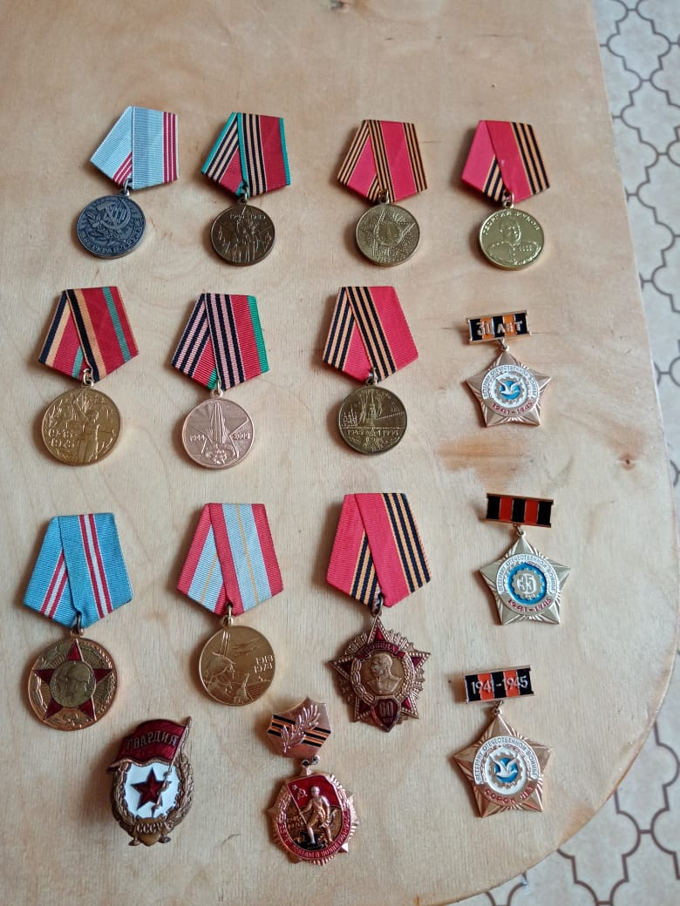
Application 6. The photographs from the war, 1944
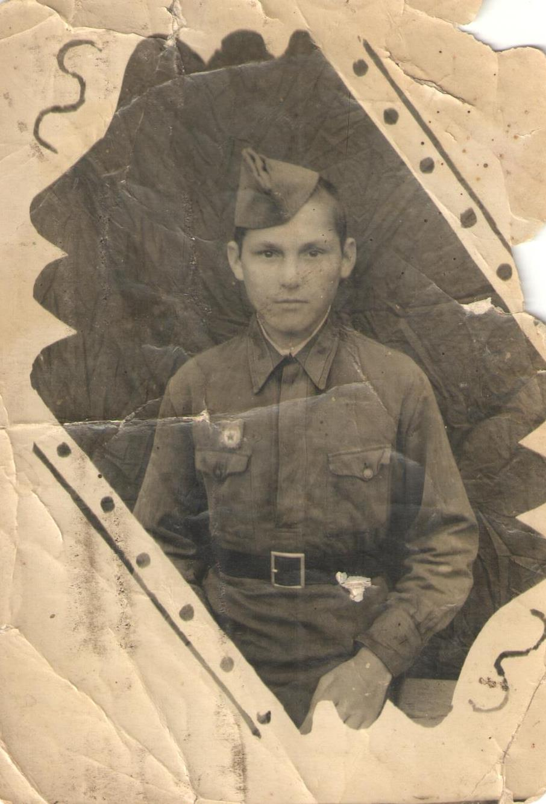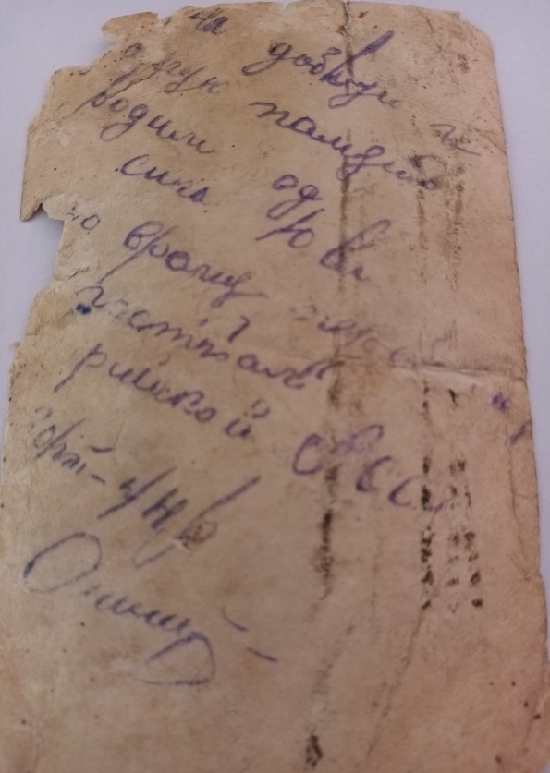

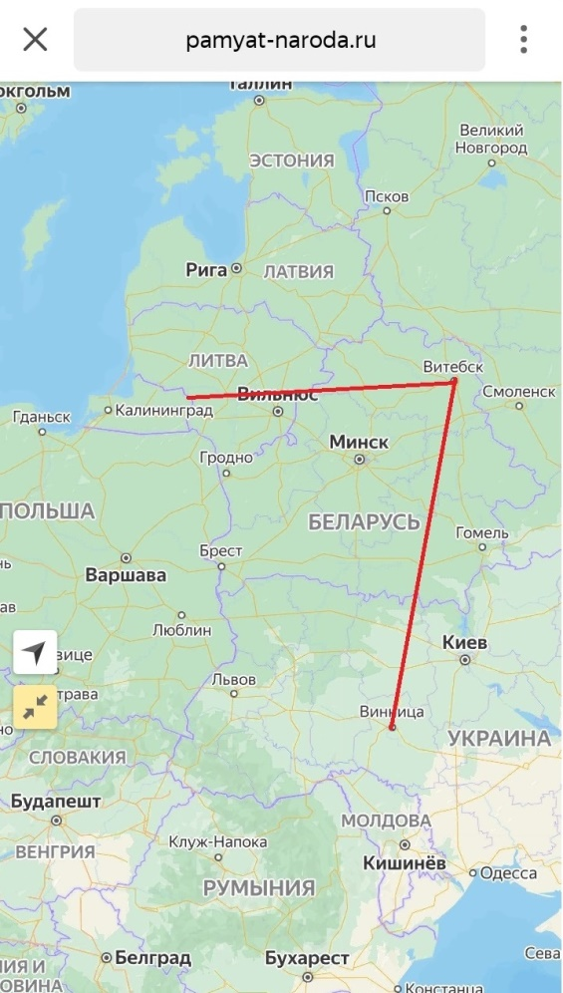

Application 6 Modern plant named after Sergo

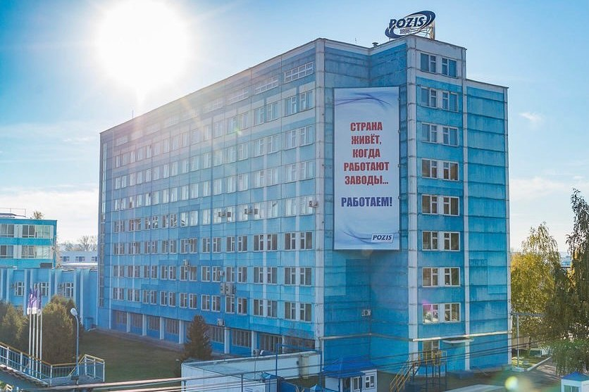

Application 7. By the 40th anniversary of victory in the Great Patriotic War,
it was necessary to build an obelisk.

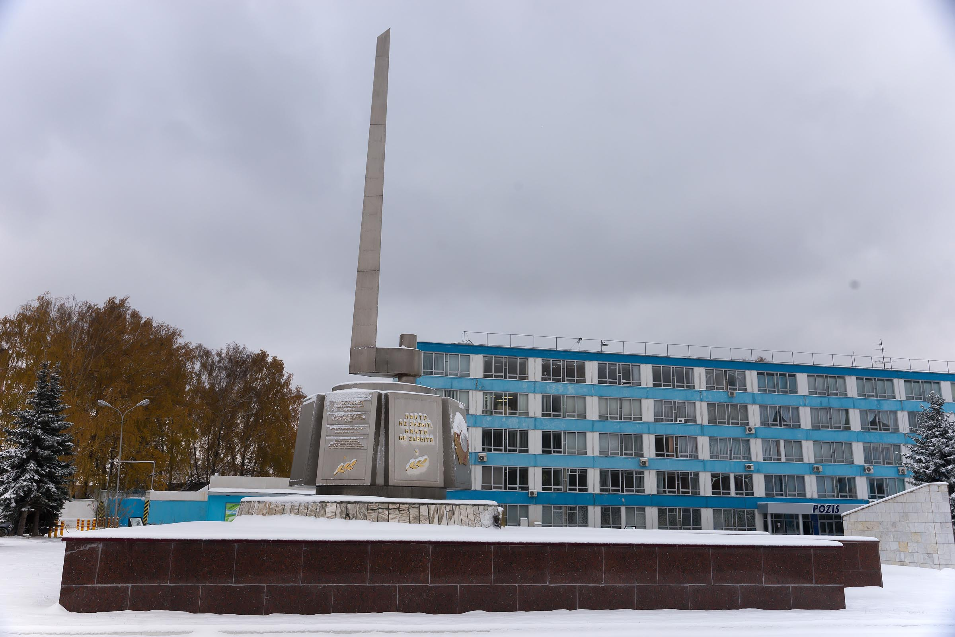

Список использованных источников и литературы

- Газета «Зеленый Дол», 19 мая 2005г, стр 4
- https://pamyat-naroda.ru (Память народа)
- http://podvignaroda.ru (Подвиг народа)
- http://dp60.narod.ru (Вставай, страна огромная!)
- https://iremember.ru (Воспоминания ветеранов Великой Отечественной Войны)
- http://www.victoryan.ru (16 января 1945 года. От Советского Информбюро)

